**2012 – 2015 Triennium Work Report**

**Chapter: Technology**

**June 2015**

**Programme Committee D3: SMALL SCALE LNG**

**Chair: Wouter Meiring**

Table of Contents²

Production 3

Layout 3

Treatment 4

Liquefaction 5

Main Equipment (incl. manufacturers) 10

Utilities and Offsites 11

Shipping 12

Outlook, growing market. 12

Hardware differences between large and small scale LNGC’s 13

Cost 14

Safety 14

Regasification terminal 15

Storage 17

BOG management 20

Logistics 23

LNG Logistics 23

Small Scale Logistic distribution methods 23

Logistic elements of the supply chain 24

Technology (overview across the value chain, incl. shipping)

Such elements have been identified as:

* Liquefaction
* Transportation
* Small Regasification Terminal
* Storage

In the remainder of this section, a functional description and technology options applicable to each section of the value chain are described.

## Production

### Layout

As in the conventional scale LNG chain, the natural gas will have to be liquefied in order to reduce its volume for an efficient transportation. The building blocks of a SSLNG production site are very similar to their conventional scale counterparts. Here, just a quick overview of the process and some considerations on how the layout can be optimized to reduce costs.

The gas first meet a feed gas receiving and metering station, which consists of pressure control, followed by liquid and solid knock-out and separation and finally temperature control and metering station (T, P, composition). Then the gas goes through the ``treating blocks’’: acid gas removal, dehydration and mercury removal. The purpose of these blocks is to eliminate those impurities (respectively CO2, H2S, H2O and Hg) which would freeze at the cryogenic temperatures reached in the liquefaction blocks and would damage the equipment.

Depending on the feed composition and the existence of a demand, an LPG/Condensate export unit might be included to monetize the heavier, and more valuable, components of the feed.

The on-spec gas can then be liquefied in liquefaction unit itself, followed by the storage and loading section.

In the remainder of this chapter, the technical details of each of these building blocks will be discussed and the main differences with their conventional counterparts highlighted.

The reduced size of the plant, compared to the conventional ones, allows achieving reduced construction times and projects schedule. Small Scale LNG plants are mostly built as modularized turnkey small-scale liquefied natural gas (LNG) solutions.

### Treatment

Like in the conventional LNG business, liquefaction of natural gas in small scale requires certain pretreatment steps. These process steps help to avoid operational disturbance of the downstream cryogenic plant section and/or ensure that the LNG product meets certain quality requirements (e.g. heating value, wobbe index, methane number). In many cases, where pipeline gas serves as feedstock to the liquefaction facility, pretreatment is less demanding and complex compared to conventional LNG business. Depending on the natural gas composition at plant inlet mercury, carbon dioxide, water, heavy hydrocarbons and nitrogen may have to be removed. Mercury is usually separated by adsorption on sulphur impregnated carbon, molecular sieves (silver doped) or metal sulfides (PURASPEC). CO2 is typically removed by a physical wash process with an amine solution. In case the CO2 content is low also an adsorptive type process may be applied. Dehydration is done with molecular sieves as adsorbent.

Heavy hydrocarbons are removed after partial condensation of the feed gas utilizing a part flow of the refrigerant cycle or. Rejection of nitrogen can be accomplished by simply flashing the LNG before storage. However this simple process step causes a significant content of methane in the nitrogen tail gas. In case this methane rich stream cannot be utilized within the liquefaction plant or routed to plant battery limit, a separation column will have to be applied. This device allows producing an almost pure nitrogen stream that can be released to atmosphere. Some technology suppliers managed to integrate heavy hydrocarbon and / or nitrogen removal steps into their liquefaction processes, which minimizes additional investment, an aspect of particular importance in small scale LNG. In conventional LNG plants removal of heavy hydrocarbons and nitrogen is usually performed in a dedicated process unit upstream respectively downstream of the natural gas liquefaction.

### Liquefaction

Three main liquefaction processes are currently employed for liquefaction at this scale: Single mixed Refrigerant, Nitrogen Expansion cycles, Mixed Refrigerant Process.

The Nitrogen Expansion process utilises a closed loop, multiple pressure level nitrogen expansion system. The nitrogen is expanded to lower pressure to provide the necessary cooling duty to liquefy the natural gas.

Single mixed refrigerant (SMR) processes use a mixture of light hydrocarbons (methane through pentane) and nitrogen that is partly condensed at ambient conditions and then used to cool the natural gas feed stream.

The process typically chosen for capacities above 0.5 mtpA is a mixed refrigerant process. For the majority of the plants this is a single mixed refrigerant process with no pre-cool. For some of the floating LNG applications nitrogen expansion processes have been proposed due to safety concerns and plot space limitations but for onshore plants they have not yet been selected in the Small Scale range. Any Small Scale trains, onshore or offshore, using an expansion process would provide a large step out from previous experience and would probably require parallel units due to the equipment sizing limits.

As the trains/plants become larger the impact of efficiency becomes more important which is why the mixed refrigerant is the prevalent process choice in this range.

A pre-cooling loop can be incorporated in any of the above processes. The advantage for the expansion processes is a higher efficiency at the cost of higher Capex and equipment count.

The pre-cooled MR process using propane as the pre-cool refrigerant is the most commonly installed process in base load LNG plants reflecting that at higher capacities the pre-cool system is advantageous. For small capacities there are very few pre-cooled processes installed.

Below is displayed a list of active technology providers for each of these methodologies:

|  |  |  |  |
| --- | --- | --- | --- |
|  | Refrigerant Type | Process | Company |
| Mixed Refrigerant Technologies | SMR | PRICO  AP-M  LiMuM  SCMR  Single MR  KSMR | Black & Veatch  APCI  Linde  Kryopak  Chart  KOGAS |
| Precooling + SMR | PCMR  OSMR | Kryopak  LNG Limited |
| Expansion-based Technologies | Single Refrigerant Expander | N2 Expander  NDX-1  OCX | Various licensors  Mustang  Mustang |
| Precooling + SRM | C3 Precooling N2 Expander  OCX-R  Niche LNG | APCI  Mustang  CB&I Lummus |

While N2 cycles are preferred for lower capacity, they are not viably efficient for production higher than 400 t/d. The SMR options, instead, should only be considered for throughput higher than 400 t/d.

|  |  |
| --- | --- |
| PRICO  (Poly Refrigerated Integrated Cycle Operation) |  |
| Company: Black & Veatch  Refrigerant: MR  MCHE: FPHE  Efficiency: Normal  Simplicity: Excellence  Reference: peak-shaving plants (about 25% of USA) |
| AP-M |  |
| Company: APCI  Refrigerant: MR  MCHE: Dual pressure SWHE  Efficiency: Good  Simplicity: Excellence  Reference: Non in the industry |
| LiMuM  (Linde Multistage Mixed Refrigerant) |  |
| Company: Linde  Refrigerant: MR  MCHE: SWHE  Efficiency: Excellent  Simplicity: Good  Reference: Shan Shan LNG Plant (China), 0.43 mtpa |
| KSMR (Korea SMR) |  |
| Company: KOGAS  Refrigerant: MR  MCHE: PFHE  Efficiency: Excellent  Simplicity: Good  Reference: Test-bed Pilot Scale Plant (Korea), 100 ton/day |
| Single MR |  |
| Company: Chart (Open Art)  Refrigerant: MR  MCHE: PFHE  Efficiency: Normal  Simplicity: Excellent (Maybe)  Reference: Sengkang LNG (Indonesia), 4 modules x 0.5 mtpa |
| PCMR |  |
| Company: Kryopak  Refrigerant:  Precooler: NH3 or C3  Liquefier: MR  MCHE: PFHE  Efficiency: Excellent  Simplicity: poor  Reference: Karrantha LNG project 0.07 mtpa |
| OSMR  (Optimized… SMR) |  |
| Company: LNG Limited  Refrigerant:  Precooler: NH3  Liquefier: MR  MCHE: PFHE  Efficiency: Excellent  Simplicity: poor  Reference: Non |
| N2 Expander |  |
| Company: Various  Refrigerant: N2  MCHE: PFHE  Efficiency: Poor  Simplicity: Excellent  Reference: Many references |
| NDX-1 |  |
| Company: Mustang  Refrigerant: N2  MCHE: PFHE  Efficiency: Poor  Simplicity: Excellent  Reference: Non (Maybe) |
| OCX |  |
| Company: Mustang  Refrigerant: MR (Part of Inlet Feed Gas)  MCHE: PFHE  Efficiency: Poor  Simplicity: Excellent  Reference: Non (Maybe) |
| C3 Precooling N2 Expander |  |
| Company: APCI  Refrigerant:  Precooler: C3  Liquefier: N2  MCHE: SWHE  Efficiency: Normal  Simplicity: Normal |  |
| OCX-R |  |
| Company: Mustang  Refrigerant:  Precooler: C3  Liquefier: MR (Part of Inlet Feed Gas)  MCHE: PFHE  Efficiency: Normal  Simplicity: Normal  Reference: |
| Niche LNG |  |
| Company: CB&I Lummus  Refrigerant:  Precooler: C1  Liquefier: N2  MCHE: PFHE  Efficiency: Normal  Simplicity: Normal  Reference: Non |

### Main Equipment (incl. manufacturers)

The main technologies are available for the cryogenic exchanger are the plate-fin heat exchanger and the coil wound heat exchanger. The pro’s and con’s of each of them are illustrated in .

Table 1 Cryogenic Heat Exchangers

|  |  |  |  |  |
| --- | --- | --- | --- | --- |
| **Cryogenic Heat Exchanger** | **Pro’s** | **Con’s** | **Capacity Range (t/d)** | **Manufacturers** |
| Plate-fin heat exchanger | * low cost per unit area * complex stream arrangement possible * readily available from many qualified suppliers | * expensive manifolding for larger pant capacities * limited acceptable temperature gradients | 20 - 800 |  |
| Coil wound heat exchanger | * large heating surface per shell * tolerant against thermal shocks * good part load behaviour * fixing of single tube leakages within moderate down time | * proprietary equipment * only one shell side stream possible | > 400 |  |

Three main types of compressors can be considered within the small scale liquefaction plant: reciprocating, screw type and centrifugal. The main characteristics and capacity range are illustrated in

Table 2 Compressors types for small scale applications

|  |  |  |
| --- | --- | --- |
| **Compressor Type** | **Characteristics** | **Capacity Range (t/d)** |
| Reciprocating | * Inexpensive * Small capacity * Reduced availability | <20 |
| Screw Type | * Insensitive to composition * Medium capacity * High reliability | 20-100 |
| Centrifugal | * Optionally integrally geared * Medium to large capacity * High reliability | 20-3000 |

In terms of compressor drivers, the alternatives are electric motors, steam turbines and gas turbines. They differ mainly in terms of optimal capacity range, but also in terms of availability, tolerance to nitrogen content in the fuel gas. The main characteristics of each of these drivers are illustrated in

Table 3 Compressor Drivers Alternatives

|  |  |  |
| --- | --- | --- |
| **Driver Type** | **Characteristics** | **Capacity Range (t/d)** |
| Electric motor | * Requires stable grid * May require NRU * High availability | 20-3000 |
| Steam turbine | * Good match in (coal) chemical   plants with HRSGs   * May require NRU * High availability | 100-3000 |
| Gas turbine | * First choice in remote areas * Sink for N2 rich fuel   (max. 20-30 vol-% N2)   * Reduced on-stream time   (maintenance) | 400-3000 |

### Utilities and Offsites

Like for world-scale LNG facilities the small-scale LNG installations require a number of utilities to enable the proper operation of the main process units. In addition the plant needs to be embedded in a suitable infrastructure providing feedstock, product outlet and accessibility for personnel and material. Many small scale LNG facilities benefit from the opportunity to use existing infrastructure (e.g. harbor, jetty, access roads, electrical infrastructure, water treatment, work force accommodation, administrative buildings), which lowers the specific costs of the overall project in comparison to the conventional LNG business.

Most small-scale liquefaction plants run their main rotating equipment on electric power. Usually no dedicated electric power production as in conventional business is installed, but the plant is connected to the public grid. This has to be suitable to take the additional load, which sometimes is a challenge in less developed regions. In this case and/or if cheap natural gas is available the main refrigerant cycle compressor may be driven by a gas turbine and/or electric power may be produced with gas engines. In rare cases a steam turbine may be utilized as a driver for the main compressor, e.g. if excess steam is available from an upstream coal gasification for substitute natural gas production, like in a few Chinese projects.

Heating is typically provided by a hot oil cycle that includes a hot oil heater operated with fuel gas taken from tank return gas or feed gas. Provided that hot water or steam is available in the vicinity of the plant, it may be utilized as alternative heating medium.

Cooling of certain process steams is mainly done by air cooling. In case a suitable cooling water source can be made available at battery limit of the plant site, this medium may be taken into consideration as an alternative cooling agent.

Instrument Air, Plant Air, Utility Nitrogen, Utility Water, Demineralized Water, Fire Fighting Water are other utilities that are usually required in small scale LNG facilities. Simpler means for providing these utilities may be applied in the small-scale business, e.g. making use of a liquid nitrogen tank instead of producing the nitrogen at site as in the conventional LNG business.

For small scale liquefaction plants based on a mixed refrigerant cycle, make-up components (e.g. ethane or ethylene, propane or propylene, butane, pentane) are required. While in world scale LNG plants these components are typically produced in a dedicated process unit, small-scale LNG plants buy these from nearby petrochemical facilities.

Depending on pre-treatment process steps installed, adsorbents/chemicals, e.g. molsieves, amine, anti foam agent are required.

LNG product outlet from small-scale LNG facilities is typically by loading on trucks. Sometimes a small jetty will be required if loading onto dedicated small LNG vessels is part of the business case. In any case marine infrastructure requirements will be less demanding than for world-scale LNG installations.

## Shipping

### Purposes

. The difference between LNG small scale ships and large scale is primarily business related .

Following purposes are followed

* Small scale LNG transport, inland and coastal, sometimes intercontinental
* Small scale LNG bunker vessel, mainly port based

SSLNG carriers lie today between 167m3 (Seagas) and 30 000m3.

The use of LNG as bunker fuel is described in the IGU report “LNG as fuel”

### Hardware differences between large and small scale LNGC’s

LNGC’s are built in line with IMO’s IGC Code and Class Society rules. The code applies to ships regardless of their size, including those of less than 500 tons gross tonnage, engaged in the carriage of liquefied gases having a vapor pressure exceeding 2.8 bar absolute at a temperature of 37.8 degree centigrade. Similar to large LNGCs, SSLNGCs normally also use the Natural Boil off Gas from the LNG cargo as fuel for purposes which may include propulsion, electrical power generation or steam generation.

So rules and regulations don’t differentiate between small and large scale LNGC’s whereas here is a business related distinction between SSLNG and large scale LNG carriers. Also, in the safety risks scenarios there are no differences from a methodolical point of view.

#### Manifold

For large LNGC’s, a distinction for manifold dimensions is made between different sizes of ships, see the overview of A, B and C below. This comes from the i.e. OCIMF publication Manifold Recommendations for Liquefied Gas Carriers. Small scale fleet ships fall under Category A.

Category (A) To 60, 000 m3

Category (B) 60,001m3 – 200,000m3

Category (C) Over 200,001m3

|  |  |  |  |  |  |
| --- | --- | --- | --- | --- | --- |
| LNG |  | Diameter (in inches) | | Horizontal distance (in meters) | |
|  | Liquid | Vapour | Horizontal Minimum | Horizontal Maximum |
| A | 12 | 8 / 12 | 2.5 | 3.0 |
| B | 16 | 12 / 16 | 3.0 | 3.5 |
| C | 16 / 20 | 12 / 16 | 3.5 | 4.0 |

Table xxx– Manifold Recommendations for Liquefied Gas Carriers, SIGTTO

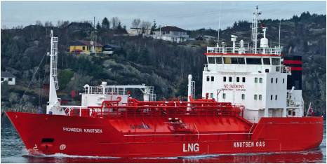 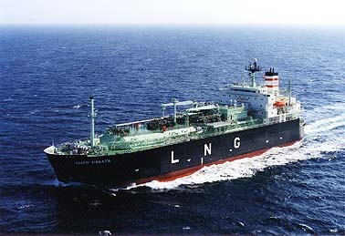 **Figure X. A Small scale pressurized LNG ship, courtesy of Shell Figure y. A large scale LNG atmospheric ship, courtesy of Shell**

#### Cargo containement

One distinctive difference between small and large scale LNG carriers is the allowable pressure in the ship. The small scale ships often have IMO type C tanks (pressure vessels), see appendices X and the larger ships have atmospheric like IMO type A (max 0.7barg), IMO type B (MOSS, max 0.7barg) or membrane (max 0.7barg however currently 0.25barg on most LNGC’s) tanks.

The advantage of type C tanks is that there is limited or no need for boil-off gas management within specified duration. I.e., the BOG will be contained within the tank resulting in rise of pressure and temperature till it reaches the designed relieving pressure of the tank. Disadvantages of Type C pressure tanks are reduced volumetric efficiency, limited tank size and increased weight compared with atmospheric tanks. See below some of the main characteristics of LNG in pressurized and atmospheric condition

* Pressurized storage (like figure X): Heat In – Boil Off Contained, LNG Temperature -126oC, density 363kg/m3
* Atmospheric storage (like figure y): Heat In – Boil Off Out, LNG Temperature -162oC, Density 423kg/m3

#### Transfer system

Another difference is the LNG transfer rate and various items including liquid flow rates typically 7-10m/s dictate the transfer rate.Typical loading rates are in the region of 200m3/hr for an 1000m3 vessel up to 2000m3/hr for a 30.000m3 vessel. Transfer rate at level of conventional LNG terminal would induce important equipment to manage BOG, transfer and massive cargo pump that would in all probability compensate the benefit of a shorter offloading time.

Where marine transfer arms are generally used for conventional onshore terminals (despite LNG hose transfer becomes a credible option), for transfer of small quantities of LNG with low flow rates, hoses can also be used. As a general guideline hoses can be used if the total volume of LNG in the hose transfer system does not exceed 0.5M3 and the length of hoses doesn’t exceed 15 meters.

Safety Features

* (often simplier such as drybreak coupling instead of power emergency release couplings)
* , often portable and relying on operator
* , which is seriously challenging considering the necessity for some operator to bunker during commercial operation

### Cost

SSLNG carriers cost is higher per ton LNG compared to large scale LNG vessels. For example a 215.000m3 LNG carrier is +/-250m$, while a 28.000m3 LNG carrier is +/-80m$. OPEX of small scale LNG carriers is also higher per ton LNG per mile compared to large scale LNG vessels.

In absolute, SSLNGCs are staffed with smaller crews and engine and cruise speed are usually well lower than conventional LNGC; this item are the most significant Opex component.

This is represented by higher daily rates or time-charter costs and is due to less economy of scale. Marine transport of LNG is therefore also a considerable part of the small scale LNG supply chain cost.

In terms of comparison of operational costs against large LNGCs , suitably designed small scale LNGC will incur reduced cost for mooring and port activities (like tug boats, pilots, shore handling, etc). In situations where ship crew operates the LNG satellite regas terminals, there are associated cost savings on terminal side too.

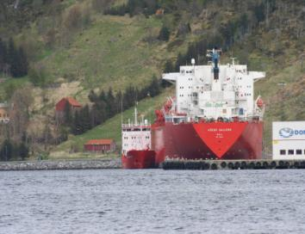

**Appendices**

**SMALL LNG CARRIERS : In service**

**SMALL LNG CARRIERS : Designs/Planned**

## Regasification terminal

Historically, regas plant grew big so as to reduce cost of regasification handling massive quantity of LNG. To remain a competitive solution, simpler processes have been used most of the time inspired by air industry player in their design (i.e. air vaporizers). This has been also possible because the footprints of small case vaporizer are acceptable for the volume of LNG handled (footprint of 0.1MTPA is equal to 1000m², where one conventional vaporizer presents a footprint below 50m² and can deliver up to 1.5MTPA).

### Specific features of a small regas plant

* Very often, these installations are unmanned. In the few cases where they are manned, the personnel is reduced to the minimum and they just show up for maintenance or unloading operation (where in some terminal personnel can reach 200 people).
* Most of the small scale regas plant are built with prefabricated equipments (like in air industry), assembled as modules directly on site, providing a faster project schedule especially regarding the tank (which is usually the long lead item on a conventional terminal).
* In some cases, pressure build up is used in tanks prior regasification instead of a pump.
* LNG inventory being less, safety study are generally lighter than the ones carried out on the conventional ones, and safety devices usually simpler.
* Maintenance is really reduced too since motorized parts and instrumentation are very few.
* Very often as well the LNG transfer is done through a flexible hose, using as emergency disconnection system a dry break coupling. Boil off gas generated naturally or due to LNG handling is contained in pressurized tank, until it gets condensed with the next subcooled delivered LNG.
* Air vaporizers are the preferred equipments for their simplicity and their absence of operating expenditures. There are several installed so as to let unfreeze vaporizers while others are on duty.
* These terminals almost never go beyond 0.3 MTPA (so far).

### Typical designs

Some terminals have capacity below 1 MTPA but uses conventional technologies found in conventional LNG regas terminals.

Conventional principle and specific small scale are depicted below for comparison and illustrate what’s written above :

#### Typical conventional:

#### Typical small scale:

## Storage

### Basic design rules

With storage and BOG management appear clearly subcategories in small scale. Whether it deals or not with small scale, sizing storage rely on good sense, and the following rules are applied as much as possible:

* + Size will be chosen so as to receive the integrality of the cargo delivered by the ship
  + Size will be therefore in the same order of magnitude than the size of the ship carrying LNG
  + The carrier ship type and size will be chosen so as to have a reasonable frequency of delivery (provided that waterways and/or road are available for that purpose).
  + Thermodynamic state of LNG (cold or warm according to customer needs)

Regular consumption of LNG and aging are constraints specific to LNG which impact the sizing of the infrastructures (big or small). Due to its cryogenic specific aspects LNG can never be stored for long (without reliquefying it).

Very simply, pressurized tank option offers the possibility to save money on BOG management expenses, and often allows to save time in realization of the installation. However, pressurized system will not be a good option when customer need cold LNG.

### Pressurized tanks

For the first category, the classical storage tank is a pressurized tank, offering possibilities to hold pressure during a given time, relieving therefore the need of managing the boil of gas of the LNG like in any conventional terminal.

Basically, a storage tank of this type, if the LNG is delivered cold, can contain BOG for one or two weeks before the next delivery that will help to recondense the BOG in the receiving tank (LNG used to refill is pumped and therefore slightly subcooled and help to recondense). The LNG offtaker of that tank might get a rather “hot” LNG.

Cooling the BOG is possible instead of letting the pressure raise, but it is less simple and probably more expansive.

Pressurized tanks have a maximal size of 1000m3 currently. They display the great advantage of being manufactured in factory saving time and money regarding works (a tank of this type is manufactured in circa 6 months ExW) . The modularity is another advantage, and it is easy to manage.

Above 1000m3, several tanks have to be installed, multiplying connections with LNG piping.

Their evaporation rate is limited by the size of the tank (as it is proportional to wet surface).

Pressurized tank raised another very serious issue which is the BLEVE.

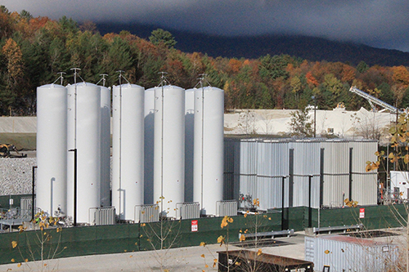

Pressurized tank farms rarely go above 5000m3 from a total capacity storage point of view.

### Spherical LNG tank

Onshore spherical tanks are reported but so far it truly concerns isolated cases. So far, clear advantages compared to bullet type if any are not yet established.

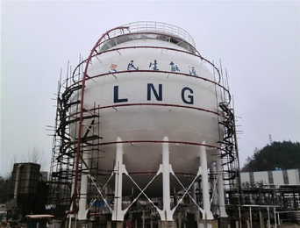

1. Atmospheric cylindrical tank

Usually built in concrete with stainless steel primary containment, they can also have an outer shell in steel as well.

The operating pressure instead allows delivering cold LNG, which can be a serious matter with some customer (bunkering for instance).

Atmospheric cylindrical tanks are usually built on site, and usually take 3 years to be built. They are usually emptied by the top which is safer than any pressurized tank. Their performance from an insulation point of view is very good.

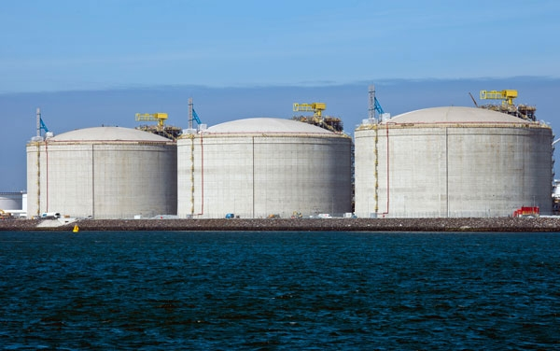 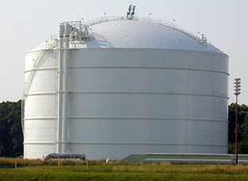

**Concrete tank Carbon steel tank**

Atmospheric type of tanks can be single containment (SC), double containment (DC), membrane tank (MT) or full containment (FC).

Conventional cylindrical atmospheric tanks are hardly competitive with pressurized tanks for small size (usually below 4 000m3). These storages cannot withstand pressure and need to have a BOG management system (see § on BOG management)

However, some atmospheric tanks can be as small as +/-2000m3.

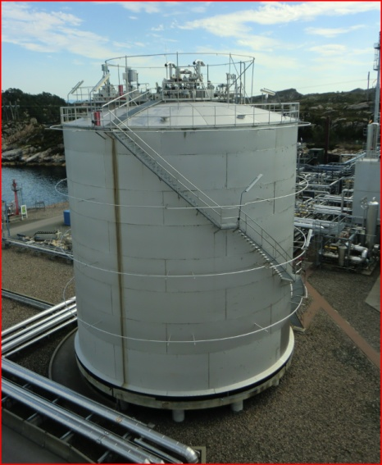

A 2000m3 FC atmospheric steel tank, courtesy of Gasnor AS (Shell).

However, very few cylindrical tanks in small size are competitive, and the smallest one are circa 10 000m3 if built in concrete for the outer shell. Cost is really local content related for this type of tank. Cost wise, the comparison between a pressurized tank and an atmospherically tank should take in consideration the BOG management associated expected investment. But choice relies not only on tank size, but also on storage duration : a BOG management system offer longer storage duration capability.

1. Atmospheric non cylindrical tank

Relying on the LNG ship industry experience, some other type of small scale storage tanks are under development. These new concepts integrate features of atmospheric tank but some strength of the pressurized one, such as modularity/flexibility and prefabricated modules. First trends show that these systems could fill the gap in the range too big for pressurized tank and too small for cylindrical atmospheric.

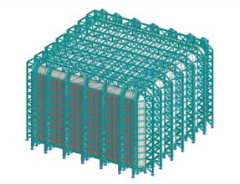

Some development are also ongoing regarding the possibility of holding a little more of BOG (however this features are studied for safety purpose and not day to day BOG management purpose)

In a first approach, facility of capacity below 0,2MTPA could grossly rely on pressurized tank, and on atmospheric for capacity above 0,2MTPA.

|  |  |  |
| --- | --- | --- |
| Tank type | Advantages | Disadvantages |
| Bullet pressurized tank | **Savings on BOG management**  Saving possibly on pumps  Pre fabricated (= fast track) | **Bleve issues**  Limited storage capacity |
| Flat bottom (atmospheric) | **No bleve possibilities**  High capacity | **Expansive**  Long item to build |
| Spherical | **Higher capacity than bullet**  Other ? | **Bleve**  Other ? |

## BOG management

Boil off gas (BOG) is a typical LNG related issue compared to other hydrocarbon fuels. Due to heat ingress, mainly the lighter parts of the liquefied gas (N2, CH4, etc) boil off

Typical boil-off rates are 0.1-0.5% per day in storage due to heat ingress. Additional BOG is formed due to the LNG left the piping that boils back to the tank, heat ingress from cooling down the pump, heat generated by the pump and vapor return from loading activities.

(recondesne/reliquefy/sent out)

When boil-off gas is removed to maintain the pressure level, the methane number decreases because the LNG gets heavier. This is important for LNG as fuel customers because most engines require a minimum methane number to prevent knocking.

If not removed, it can be contained under pressure. Pressure will be decreased by emptying the tank and/or refilling it with subcooled LNG recondensing BOG.

BOG is an important aspect in the LNG supply chain that must be taken into account during the complete design, execute and operate phases.

The BOG management required at various supply chain stages depends mainly on pressure build-up that can be allowed in the supply chain from liquefaction to end-customer. Large LNG customers are mostly energy consumers/producers (like regas to power plants) using atmospheric storage (pressure slightly above 1 bara). Most of the time the LNG is off taken from this facilities under a gaseous form . This requires the. Hence the large scale LNG supply requires significant BOG management all over the chain.

Small customer like LNG for transport or small regas facilities can use pressurized storage (pressurized single containment tanks are currently available up to 1200m3). In this case different (less) BOG management is required to manage the pressure to be below max operating pressure at the customer.

The BOG management system (removal) will help to keep LNG colder. An LNG cold stored under atmospheric pressure can be delivered to any type of customer. An LNG stored under pressure (therefore warm) can only be delivered to a customer that has the same type of pressure storage unless the BOG has been removed before.

The main differences between small and large scale LNG BOG management are summarized in the table below;

|  |  |  |  |
| --- | --- | --- | --- |
| LNG Scale | Liquefaction | Transport | Storage before end-customer |
| Small | Pressurized or atmospheric LNG storage.  BOG management for example by compression/re-liquefaction. | Shipping: pressurized up to ~4barg or atmospheric.  Road: pressurized up to 3 - 8barg.  Rail: pressurized up to 3 - 8barg.  BOG management for example by top spray, subcooled LNG and vapor return. | Regas terminal: pressurized storage (max volume per single vessel)  Bunker terminal/ship: pressurized, however trend for bunkering larger vessel is atmospheric.  Retail (road/rail): pressurized.  BOG management for example by throughput, top-spray, subcooled LNG or re-liquefaction. |
| Large | Atmospheric LNG storage.  BOG management for example by compression/re-liquefaction. | Shipping: atmospheric.  BOG management for example by via compression/re-liquefaction and vapor return. | Atmospheric LNG storage.  BOG management for example by compression/re-liquefaction. |

|  |  |  |  |  |
| --- | --- | --- | --- | --- |
|  | BoG Management at Production | Transport | Receiving facilities | Possible end customer |
| Pressurized | No | Pressurized | Pressurized | … |
| Atmospheric | Yes | Pressurized or Atmospheric | Pressurized or Atmospheric | … |

For small regas customers using pressurized storage, pressure-build up can positive because for example there is no need for a LNG pump (but control on flow rate is lesser). On these terminals, BOG (pressure build-up) can be handled solely by sufficient throughput, sub cooled LNG and vapor collapse (top spray).

In the current LNG for transport market, there are different end pressures required per geographical location and per customer type. The smaller marine customers typically have pressurized storage while the larger marine customers move towards atmospheric storage. For road and rail customers, the pressure required is defined by engine type. For example in the US, Asia and Europe, fuel station have different delivery pressure and are thus requiring different BOG management systems. The table below shows measures that can be taken to reduce BOG production and minimize consequences of BOG production;

|  |  |  |  |
| --- | --- | --- | --- |
| BOG mitigations | Mode | Plus | Minus |
| Top spray | LNG transfer | Effective, vapor collapse  Low cost solution | Requires internals and topfill line + ESD valves  Only is pressurized tank |
| Vapor return | LNG transfer | Relative low cost solution | Extra connections/piping required, potential leak sources  Changes the location of where BOG needs to be handled with, doesn’t solve it  Contribute to solution, but rarely a standalone solution (depending on flowrate) |
| BOG compressor | LNG transfer & storage | Allows BOG to be used as fuel gas/ regen gas or re-liquefy  Enables to keep pressure constant  Can be single BOG management mitigation method | Very costly  Maintenance, reliability  If subject to high flow changes, need an bypass to flare/vent |
| Minimize heat ingress | LNG transfer & storage | Effective  Many options available (superinsulated/ vacuum/ PUR/ EPS/ PIR)  Can be double containment (safety) | Increase CUI probability  Contribute to solution, but rarely a standalone solution (depending on flowrate) |
| High throughput | LNG storage | Very effective  No CAPEX | Most effective with sub-cooled LNG  Limited by customer demand and optimal parcel size  Contribute to solution, but rarely a standalone solution (depending on flowrate) |
| Pressurized storage | LNG storage | Allows more BOG accumulation.  Could eliminate the need for pumps | Max volume constraints  End-customer constraints |
| In tank Re-liquefying (coil) | LNG storage | Allows BOG intake  Enables to keep pressure constant | Requires another cryogenic tank  Coolant refilling required |

There have been reports that in small scale LNG, especially during transport, trucks and ships depressurize their tanks to atmosphere to remove BOG before loading/unloading. This happens because the pressure-build up during transport or even filling pressure does not fit within operating window of the receiving point.

Methane venting reduces the environmental benefit of using LNG significantly (in terms of global warming, an international issue). It also introduces safety issues when vent valves are mistakenly left open or when venting are done at a location without ignition control. Because LNG is promoted as a more environmental friendly fuel than coal/ HFO or other fuels, this could damage reputation.

There would be a great benefit in creating industry standards and regulation such that in operation of the plant/ terminal or supply chain, it can be proven that no venting will occur due to insufficient BOG management.

## Logistics

### LNG Logistics

#### Supply chain logistics

Success of the (small scale) LNG supply chain is the associated logistics. This is important within the operations as it permits the flow of (liquefied) gas through the chain whilst minimizing production downtime and ensuring timely deliveries with a fit-for-purpose shipping fleet. It is also important in a project design phase as LNG storage and loading facilities require major CAPEX. A thorough analysis of required storage and loading configuration, shipping fleet and customer profile provides insight in required export facilities and CAPEX.

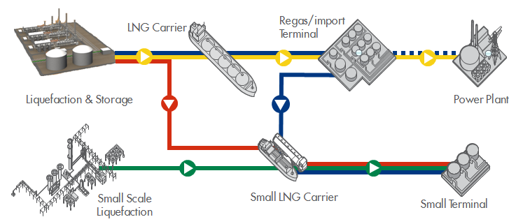

Figure 1: Five different logistic LNG distribution methods. The yellow line shows the conventional way of LNG distribution. The others represent a small scale variant. Namely: the green line represents SSLNG solely, the red line represents SSLNG at liquefaction, the blue including the blue dotted line represents SSLNG at regasification and the blue without dotted blue line represents SSLNG at import terminal.

### Small Scale Logistic distribution methods

To perform a logistic analysis it is important to define the applied logistic distribution network. Starting from the conventional LNG supply chain, several Small Scale variants can be derived (Figure 1). An obvious example of a Small Scale distribution can be obtained by adding to the conventional supply chain a Small Scale demand source, so for instance adding the possibility for small LNG carriers or trucks to off-take LNG volumes from either the tanks at the regasification terminal (i.e. SSLNG at regasification, blue line and dotted blue line in Figure 1) or at the liquefaction terminal (i.e. SSLNG at liquefaction, red line in Figure 1). Currently most commonly applied is the SSLNG at regasification terminal since these terminals are usually located closer to the demand. A variant of this last distribution method is a situation in which the demand of LNG is solely coming from Small LNG Terminals. In this case, there is no regasification, and the facility receiving the LNG is called import terminal (i.e. SSLNG at import terminal, blue line in Figure 1). A fourth small scale distribution method consists of only Small Scale LNG activities (i.e. SSLNG solely, green line in Figure 1). This can be for instance a small liquefaction plant that sources small scale carriers that supplies regasification terminals or other downstream activities such as gas to transport.

### Logistic elements of the supply chain

Conventional logistic analysis mainly focuses on the LNG transport between liquefaction plant and regasification/import terminal. For a solely Small Scale distribution method (green line in Figure 1), the situation is very similar.

When the Small Scale LNG is derived as a branch of a conventional LNG chain, the logistics aspects are more complex as also the Small Scale distribution step to a Small Terminal needs to be taken into account. This is important since it logistically affects the conventional transport step and therefore has impact on the overall logistic performance. For example, if small scale carriers are using the same berth and port as the conventional LNG carriers, the berth utilization or ship waiting time is impacted.

Figure : Elements within the logistic supply chain.

To perform a logistic analysis for a conventional transport by large LNG carrier, the supply chain is further broken down into elements. Each of these elements impact the overall logistic performance of the supply chain (Figure 2).

Logistic analysis of a Small Scale supply network can be done in a very similar way (Table 1). However the logistic behavior of each element can be very different, because for instance the reliability of the small carriers is different, shipping distances are shorter or the number of customers is different.

Table : Logistic elements within supply chain

|  |  |  |
| --- | --- | --- |
| Element | Conventional transport | Small Scale transport |
| Supply | Liquefied gas from LNG plant | LNG plant, Regas/Import terminal/Small Scale Liquefaction plant carrier |
| Storage | Tanks at LNG plant | Tanks at production/import/regasification terminal |
| Transport Lines | Jetty | (Jetty) |
| Loading Facility | Berth | Berth or loading dock |
| Transport | LNG carriers | Small LNG carrier or trucks |
| Demand | Customers at import/regasification terminal | Customers at small terminal |

Elements to build the supply chain

The starting point is obviously the customer demand. From this point, an iterative exercise can be carried out to find out what is the best balance from a cost standpoint between the size of the infrastructures at both ends and the fleet

But other challenging parameters have also to be considered to build properly the chain:

* + Size range of the fleet
  + Berth or bay, facilities availability in general
  + Availibilities of the fleet on market as backup in case of problem
  + Aging of LNG and BOG management (ruling in some cases the delivery frequencies)
  + Environmental risk on the chain (meteo…)

The challenges to arbitrate are reported below

|  |  |
| --- | --- |
| Small fleet | Big fleet |
| "Big" ship | "Little" ships |
| Big marine infrastructure, tugs…higher CAPEX | = limited size infrastructure…low CAPEX |
| Cost effective per m3 transported | distributed risk on the fleet in case of failure |
| Lower berth occupancy | Higher delivery frequency |

#### Modeling the supply chain and performance measures > input Reinier

1. Why (and how) do we model logistic supply chain?
   1. to obtain performance measures
   2. difficult interrelation between logistic elements

This does result in the LNG supply chain being complex as several discrete segments have to work in unison to ensure continuous and secure supply of gas; these include upstream facilities, liquefaction plant with LNG storage, shipping export, import terminals with regasification and delivery to the customer.

1. What performance measures are important?

* Storage requirements > CAPEX: does scope stay same for SSLNG?
* Number and characteristics of berth and jetty
* Fleet configurations

#### Differences between small scale and conventional

* Different logistic elements for SSLNG and conventional can be compared
  + Eg. For small scale: need to take into account also other events. E.g. if transport by truck, traffic jams, road works, …
  + ADP: Does a small value chain require for more contingencies and flexibility in the planning? Same kind of contracts?
  + Take trucking into account >0.1 mtpa. How far can you truck, limitations?
  + Shipping: how far economically and technical BOG.
* Different performance measures of SSLNG and conventional can be compared (e.g. ).

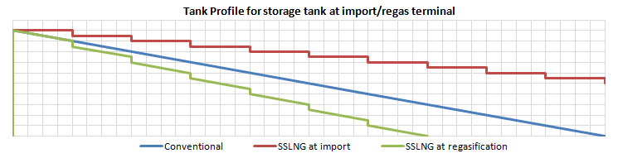

Figure : Tank profile for tank at import/regasification terminal for different (small scale) distribution methods.

#### Example case of small scale LNG transport (fictitious examples)

* Number of fleet vs. distance for different production
* Two customers

#### Conclusion

* Challenges?
* Future outlook?
* Recommendations?